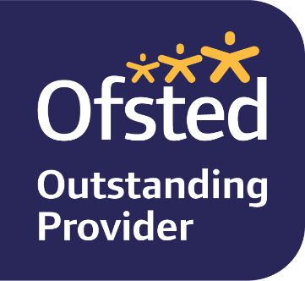

Staff vacancy for SENCO/Co-Keyperson

We are a term time Monday – Friday pre-school based in St Peters Church Centre, Ash. We are looking to recruit a Qualified SENCO to join our friendly team as an Early Years Senco/ Co-keyperson for 4 -5 days per week from June 23. The hours to be worked will be between 8.30am – 2pm depending on the day (we can be flexible for the right candidate with core hours being 9am – 1.15pm)
Must have:
- Experience/training relevant to the Senco role within an early years environment
- A full and relevant level 2 or 3 Early Years/childcare qualification
- An inclusive approach including an empathy with the Christian foundation and ethos of Little Fishes
- ability to recognise, plan and support children who need additional support
- ability to liaise with parents and other professionals.
- attention to paperwork and willingness to learn procedures relating to SEN provision
- commitment to families with young children, equal opportunities and safeguarding
- friendly, flexible approach
Good to have:
- first aid certificate
- dbs registered on the update service

Please email us for a full job description. Rate of pay depending on qualifications.
Applicants should request an application form by email sent to:- bigfish@littlefishes.me.uk Only official forms will be considered. Potential applicants are welcome to call on 01252 317293 or email to find out more about us or the role, or to make an appointment to visit the setting prior to applying. Closing date for applications - Tuesday 30th May 2023.
Interviews will be held in the morning at St Peter’s Centre, Ash, week beg 5th June day tbc.
Please note this role is subject to an enhanced DBS check and suitable references being obtained by us prior to employment commencement.

